**URL: http://www.specialty-hospital.com/**

The Quality Management department is one of the vital departments in the specialty hospital, it oversees quality management and performance improvement issues in all areas and functions of the hospital. It aims to continually improve its quality of services and patient care processes and outcomes. It aims to continually improve its quality of services and patient care processes and outcomes. To provide the highest quality, comprehensive healthcare services, provided in a safe, comfortable, well managed facilities by highly qualified professionals in the most cost effective manner in order to generate a profits, while at the same time meeting and exceeding customer expectations

|  |
| --- |
| **Specialty Hospital Core Values**  · ·          Ethical and cultural sensitivity: Being sensitive to ethical and cultural background of patients, visitors and Ethical and cultural sensitivity: Being sensitive to ethical and cultural background of patients, visitors and         employees. employees.  · ·          Excellence: delivering excellence in all clinical and non-clinical activities. Excellence: delivering excellence in all clinical and non-clinical activities.  · ·          Compassion: responding to the emotional needs of patients and their families, during the healing process. Compassion: responding to the emotional needs of patients and their families, during the healing process.  · ·          Teamwork: recognizing the power of coordinated input in managing projects, and in the delivery of care. Teamwork: recognizing the power of coordinated input in managing projects, and in the delivery of care.  · ·          Innovation: operating with a commitment to seeking out and providing effective progressive procedures. Innovation: operating with a commitment to seeking out and providing effective progressive procedures. |

**Photos**

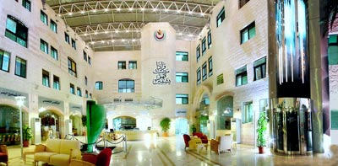

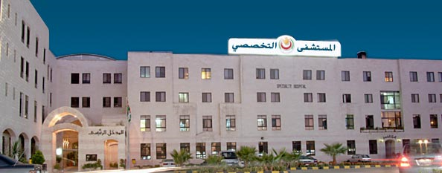

Address: Ibn Hayyan St. - Shmeisani / Amman, Jordan  
P.O.Box: 930186 Amman 11193 Jordan.

**E-mail:** [**Info@specialty-hospital.com**](mailto:info@specialty-hospital.com) **Web site : www.specialty-hospital.com**

|  |  |  |
| --- | --- | --- |
| **Tel.:**  **Cell.:**  **Fax:**  **Video:** | **(+962-6)**  **(+962-79)**  **(+962-6)**  **(+962-6)** | **5001111**  **5569-654**  **5697 -425**  **5609-610** |
|  |  |  |

**Anesthesia**

**Doctor’s in Anesthesia department:**

Head of Anesthesia Department   
Jordanian Board of Anesthesia and Intensive Care 1989  
Jordan University - Amman   
MD. Rijeka – Yugoslavia 1982.

**Dr. Abbas S. Altawil**

**Specialist of Anesthesia  
Jordanian Board in Anestheaia and Intensive Care 1986  
MD. Iskanderieh - Eygpt 1996.**

**Naheel A. Al-Anani**

**Specialist of Anesthesia   
Jordanian Board of Anesthesia and Intensive Care 1996  
Jordan University- Amman 1996  
MD. Zagreb. - Yugoslavia 1988**

**Dr. Jamal Ali Shrouf**

Specialist of Anesthesia   
Jordanian Board in Anesthesia and Intensive Care 1999  
MD. Romania. 1982

**Dr. Saleh N. Alali**

ا

**Specialist of Anesthesia  
Jordanian Board in Anesthesia and Intensive Care 2001  
MD – Germany 1994**

**Dr. Muwaffaq N. Abu- Tah**

**Specialist of Anesthesia  
Jordanian Board in Anesthesia and Intensive Care 2003  
MD. Croatia 1986.**

**Dr. Rafat A. Odeh**

pecialist of Anesthesia  
Jordanian Board in Anestheaia and Intensive Care 2005  
MD. Pakistan 1996

**Dr. Baker SH. Abdelha**

**Higher Diploma of Anesthesia 1986   
FRCA Part I 1988  
MD. Baghdad - Iraq 1982**

**Dr. Aisar D. Salman**

**Jordanian Board In Anesthesia And Intensive Care 2007   
Arab Board In Anesthesia And Intensive Care 2007   
MD.Aleppo - Syria 2000.**

**Jordanian Board In Anesthesia And Intensive Care 2007   
Arab Board In Anesthesia And Intensive Care 2007   
MD.Aleppo - Syria 2000.**

Assem Bal'awi : Consultant chest & heart surgery

Dental & Mouth Surgery

Shafiq Al-Saadi   Consultant Dentist

Mohammad Sudqi   Consultant Dentist

Endocrine Diseases

Mohammad Jum'ah   Consultant Endocrine Diseases

Eye Surgery

Ibrahim Ashouri   Consultant Ophthamologist

Sura Sabel-Eish   Consultant Ophthamologist

Ali Al-Hunaidi   Consultant Ophthamologist

General Surgery

Marwan Salah   Consultant General Surgeon

Zaki Qula Ghassi Consultant General Surgeon

 Ghazi Ramadan   Consultant General Surgeon

 Farhan Yassen   Consultant General Surgeon

Dawood Al-Mohtaseb   Consultant General Surgeon

Mustafa Steitiyeh   Consultant General Surgeon

Ahmad Al-Omari   Consultant General Surgeon

Haidar Al-Taweel   Consultant General Surgeon

Hematology

Mohammad Salameh   Consultant Hematologist

  Adnan Abu Rajab   Consultant Hematologist

  Nabeel Alloush   Consultant Hematologist

Maysara Alqam   Consultant Hematologist

Sami Al-Khatib   Consultant Hematologist

  Infectious Disease

Jamal Wadi   Consultant Epidemiologist & Communicable Diseases

Neurology

Ibrahim Adam   Consultant Neurologist

  Ahmad Shihab   Consultant Neurologist

Neurosurgery

Ibrahim Sbaih   Consultant Neurosurgeon

Isshaaq Maraqa   Consultant Neurosurgeon

Ali Al-Jammal   Consultant Neurosurgeon

Mohammad Samaha   Consultant Neurosurgeon

Obstetric & Gynocology

Mohammad Jaabari   Consultant Obstetrician Gynocologist

  Majida Al-Jallaad   Consultant Obstetrician Gynocologist

Boran Taha   Consultant Obstetrician Gynocologist

Fayez Abu-Humeidan   Consultant Obstetrician Gynocologist & IVF

Ihsaan Mbaideen   Consultant Obstetrician Gynocologist

 Fawzi Abu-Humeidan   Consultant Obstetrician Gynocologist

Bassem Abu-Humeidan   Consultant Obstetrician Gynocologist

Zuhair Abu-Faris   Consultant Obstetrician Gynocologist

Sahar Al-Khalili   Consultant Obstetrician Gynocologist

Abdul-Malek Abdul-Malek   Consultant Obstetrician Gynocologist

Mohammad Nazeeh Kayyali   Consultant Obstetrician Gynocologist

Oncology Surgery

Zaki Qula Ghassi   Consultant General Surgeon

Ghazi Ramadan   Consultant General Surgeon

Farhan Yassen   Consultant General Surgeon

Orthopedic Surgery

Tayseer Sabri   Consultant Orthopedic Surgeon

  Wael Abu Khalaf   Consultant Orthopedic & Knee Surgeon

e-mail: [wakhalaf@hotmail.com](mailto:wakhalaf@hotmail.com)

[www.kneespecialty.com](http://www.kneespecialty.com)

  Maher Youssef   Consultant Orthopedic Surgeon

Hatem Al-Rawashdeh   Consultant Orthopedic & Knee Surgeon

  Nabeel Hamdan   Consultant Orthopedic Surgeon

Pediatric

Fawzi Al-Hammouri   Consultant Pediatrician & Endocrinologist

Samir Al-Humeidi   Consultant Pediatrician

Wa'el Sunnokrot   Consultant Pediatrician

Plastic Surgery

Rif'at Sukkaji   Consultant Plastic Surgeon

Omar Shobaki   Consultant Plastic Surgeon

Pulmonology

Ayman Abdussalam   Consultant Pulmonologist

Khamis Khattab   Consultant Pulmonologist

Samir Diab   Consultant Pulmonologist

Skin & Veneral Disease

Yossef Al-Damen   Consultant Dermatologist

Urology Surgery

Nour Al Din Alawneh   Consultant Gentio-urologic & Renal Surgery

Talal Tahboub   Consultant Gentio-urologic & Renal Surgery

Abdulkareem Zeitawi   Consultant Gentio-urologic & Renal Surgery

Vascular Surgery

Consultant Vascular Surgeon & Kidney Transplant

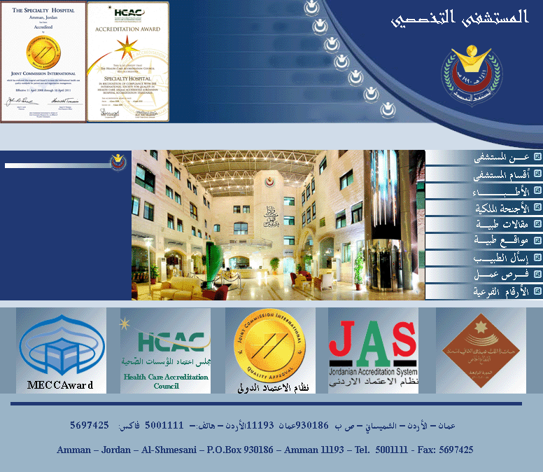

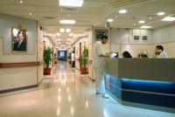 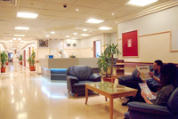

Technical Department

[C.C.U. & I.C.U.](http://www.specialty-hospital.com/main/inside/divisions/CCU.htm)   [Lithotripsy Unit](http://www.specialty-hospital.com/main/inside/divisions/stones.htm)   [Corneal Transplantation Department](http://www.specialty-hospital.com/main/inside/divisions/cornia.htm)   [Maxillofacial Surgery](http://www.specialty-hospital.com/main/inside/divisions/teeth.htm)   [Cozmo Laser Center (for laser treatment)](http://www.specialty-hospital.com/main/inside/divisions/cozmo-laser.htm)   [Medical Laboratory](http://www.specialty-hospital.com/main/inside/divisions/lab.htm)   [Dialysis Unit](http://www.specialty-hospital.com/main/inside/divisions/kidney-wash.htm)   [Neonatal Intensive Care Unit](http://www.specialty-hospital.com/main/inside/divisions/birth-defect.htm)   [Emergency Department](http://www.specialty-hospital.com/main/inside/divisions/emergency.htm)   [Nuclear Medicine Center](http://www.specialty-hospital.com/main/inside/divisions/nuclear.htm)   [Endoscopy](http://www.specialty-hospital.com/main/inside/divisions/scope.htm)   [Nutrition & Slim Clinic](http://www.specialty-hospital.com/main/inside/divisions/nutrition.htm)[Radiology Department](http://www.specialty-hospital.com/main/inside/divisions/radiation.htm)   [Heart Center](http://www.specialty-hospital.com/main/inside/divisions/open-heart.htm)   [Physiotherapy & Rehabilitation Center](http://www.specialty-hospital.com/main/inside/divisions/physical.htm)   [Hyperbaric O2 Therapy](http://www.specialty-hospital.com/main/inside/divisions/oxygen.htm)   [Specialty Optics](http://www.specialty-hospital.com/main/inside/divisions/opticos.htm)   [I.V.F. Genetics Lab](http://www.specialty-hospital.com/main/inside/divisions/fertility.htm)   [The Operating Rooms](http://www.specialty-hospital.com/main/inside/divisions/surgery-smb.htm)   [Labour Room](http://www.specialty-hospital.com/main/inside/divisions/birth.htm)   [Vision Correction Center](http://www.specialty-hospital.com/main/inside/divisions/eye-laser.htm)   [Anesthesia Department](http://www.specialty-hospital.com/main/inside/divisions/T7%27deer.htm)   [Radiology Department](http://www.specialty-hospital.com/main/inside/divisions/Radiology.htm)